Potentiometer Documentation
by Eric LIU

Objective: using potentiometer and develop application based on linear equations from analog output. e.g. Dimmable LED light / Binary counter using potentiometer as value alterner.
Components:
- Part 1:
  - Potentiometer 50kΩ x1
  - Resistor 220Ω x1
  - LED x1
  - jump wires
  - Arduino setup
- Part 2:
  - Potentiometer 50kΩ x1
  - Resistor 220Ω x9
  - Resistor 1kΩ x4
  - LED x4
  - Jump wires
  - 7 segments LED
  - Arduino setup
Part 1:
Schematics:
Part1:
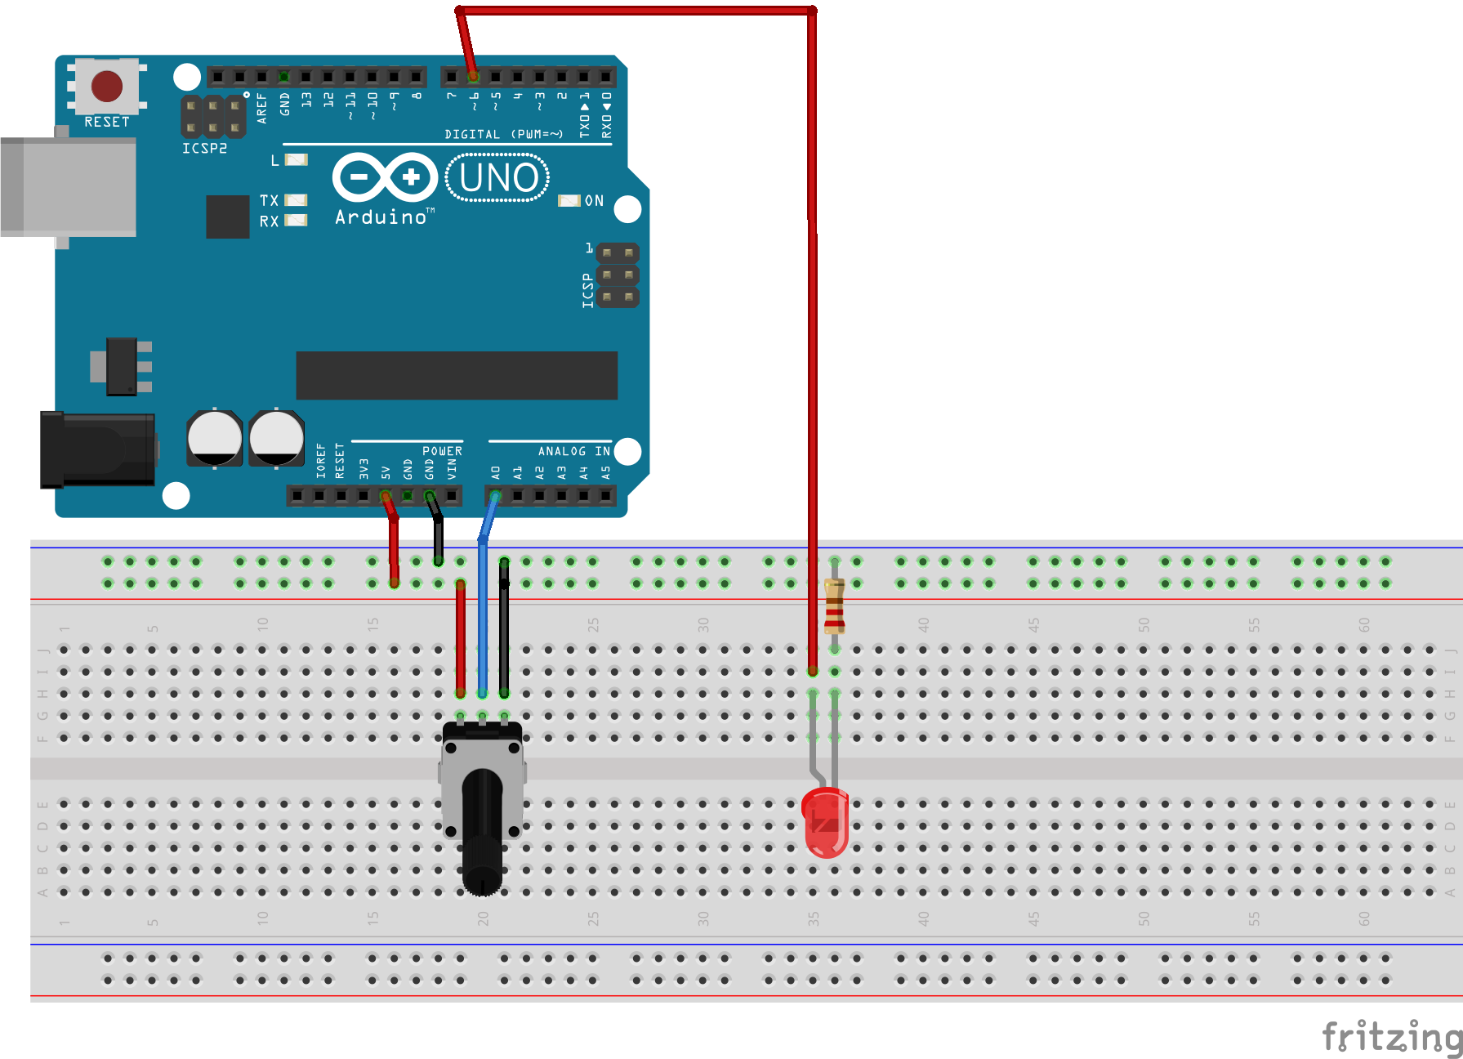

Code:

1  2  3  4  5  6  7  8  9  10  11  12  13  14  15  16  17  18  19  20  21  22  23  24  25  26  27  28  29  30  31  32  33 | int potPin=A0; //set potentiometer to analog pin  int ledPin = 6; // important: use the pin with a ~beside the number!!  int dt = 0; //usually put 250 to debug;  int valueAna;  float valueLed;  float valueVolt;  void setup() {  Serial.begin(9600); //9600 baude rate on serial monitor  pinMode(potPin, INPUT);  pinMode(ledPin, OUTPUT);  }  void loop() {  valueAna = analogRead(potPin);  //Serial.print("Analog value is ");  //Serial.println(valueAna);  delay(dt);  //equation for voltage = (5/1023) * Read Value  valueVolt = (5./1023.)*valueAna; //valueVolt in float!!  //Serial.print("Real world voltage is ");  //Serial.println(valueVolt);  //equation for analog write = (225/1023) * Read Value  valueLed = (255./1023.)*valueAna;  analogWrite(ledPin,valueLed);  Serial.println(valueLed);  }

Since at peak voltage (5V), analog value is 1023, which is a 10bits value. We can obtain the equation as followed:

We can enable the codes from line 19, 20, 25, 26 to verify if the value is correct on serial monitor.

Thus, the expression of analog write in respect to voltage will be:

By replacing Voltage with the expression obtained previously, we obtained:

Part 2:
Objective: Based on the concept and methodology developed previously, create a 4-bits binary counter while showing value with a hex 7 segments LED. Value alters from the value of potentiometer.

Schematics:
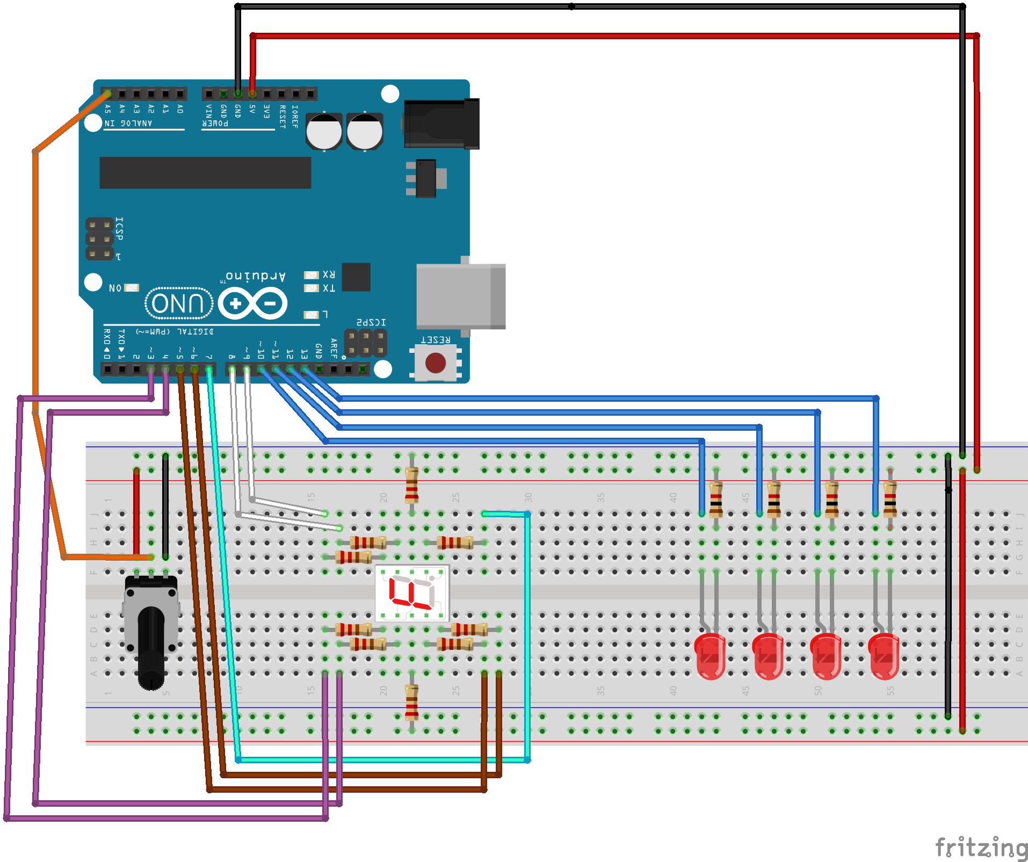
Code:
#define LIMITARR 10
int potPin=A5; //set potentiometer to analog pin
int ledPin[]={13, 12, 11, 10};//LED corresponding to 2^0 is pin 13, in a decreasing order
int dt = 0; //usually put 250 to debug;
int valueAna;
float valueVolt;
int dimBit = 4;
int digVal;
int maxDigVal=pow(2,4)-1;
int binaryArr[LIMITARR];
//position for 0-F (16) based on a-f (7)
int segLED[16][7]={
{1,1,1,1,1,1,0},
{0,1,1,0,0,0,0},
{1,1,0,1,1,0,1},
{1,1,1,1,0,0,1},
{0,1,1,0,0,1,1},
{1,0,1,1,0,1,1},
{1,0,1,1,1,1,1},
{1,1,1,0,0,0,0},
{1,1,1,1,1,1,1},
{1,1,1,1,0,1,1},
{1,1,1,0,1,1,1},
{0,0,1,1,1,1,1},
{1,0,0,1,1,1,0},
{0,1,1,1,1,0,1},
{1,0,0,1,1,1,1},
{1,0,0,0,1,1,1}
};
int segPin[]={9,8,7,6,5,4,3};

void setup() {
Serial.begin(9600); //9600 baude rate on serial monitor
pinMode(potPin, INPUT);
for(int i=0; i<dimBit;i++){
pinMode(ledPin[i],OUTPUT);
};
for(int j=0; j<7; j++){
pinMode(segPin[j],OUTPUT);
};

}

void loop() {
valueAna = analogRead(potPin);
//Serial.print("Analog value is ");
//Serial.println(valueAna);
delay(dt);

//equation for voltage = (5/1023) * Read Value
valueVolt = (5./1023.)*valueAna; //valueVolt in float!!
//Serial.print("Real world voltage is ");
//Serial.println(valueVolt);

//expression for data conversion
//max number
//Serial.println(maxDigVal);
digVal = maxDigVal/5 * valueVolt;
//Serial.println(digVal);
binaryCoder(dimBit, digVal);
ledFlasher(dimBit);
segLEDFlasher(digVal);
}

void binaryCoder(int inputBit, int inputNum){
int quotient, remainder, devidend, devisor, i, j;
// initial variables
devidend = inputNum;
devisor = 2; //in binary, so 2
for(i=0; i<inputBit; i++){
quotient = devidend / devisor;
remainder = devidend % devisor;
devidend = quotient;
binaryArr[i] = remainder;
};
Serial.print("Input number is: ");
for(j=inputBit-1; j>=0; j--){

Serial.print(binaryArr[j]);
};
Serial.println("");
}
void ledFlasher(int inputBit){
int i;
for(i=0; i<inputBit; i++){
if(binaryArr[i]==1){
digitalWrite(ledPin[i],HIGH);
}
else if(binaryArr[i]==0){
digitalWrite(ledPin[i],LOW);
};
};

}

void segLEDFlasher(int inputNum){
for(int i=0; i<7; i++){
if(segLED[inputNum][i]==1){
digitalWrite(segPin[i],HIGH);
}
else{
digitalWrite(segPin[i],LOW);
};

Serial.print(segLED[inputNum][i]);

}
Serial.println("");
}

